FIRST INVESTIGATION OF SUBMARINE CAVES AND TUNNELS ON TRINDADE ISLAND, SOUTHEASTERN BRAZIL (SOUTHWESTERN ATLANTIC), AND THEIR SPONGE COMMUNITIES

Francisco L. P. Moraes
Faculdade de Oceanografia,
Universidade do Estado do Rio de Janeiro.
E-mail: chicolpmoraes@hotmail.com
Fernando C. Moraes
Departamento de Invertebrados,
Museu Nacional, Universidade Federal do Rio de Janeiro; e
Instituto de Pesquisas Jardim Botânico do Rio de Janeiro.
E-mail: fmoraes@mn.ufrj.br
Guilherme Muricy
Departamento de Invertebrados,
Museu Nacional, Universidade Federal do Rio de Janeiro; e
Instituto de Pesquisas Jardim Botânico do Rio de Janeiro.
E-mail: muricy@mn.ufrj.br
Joel Braga
Instituto Mar Adentro.
E-mail: jbraga@maradentro.org.br
Joana Sandes
Departamento de Invertebrados,
Museu Nacional, Universidade Federal do Rio de Janeiro.
E-mail: jcfsandes@gmail.com

ABSTRACT: In this study, we investigated for the first time the possible existence of submarine caves in Trindade Island, an isolated oceanic island off Southeastern Brazil, and their sponge communities. Six sites were visited around the island, and a small cave was discovered at Goat Beach (“Praia das Cabritas”). This cave has a narrow entrance at 6 m depth, leading to a disphotic room approximately 6 m long, colonized mainly by abundant sponges of the genus Agelas. It also has a transition zone with fewer sponges, leading to narrow passages that remain unexplored. There is a semi-submerged tunnel at Big Wall Point (“Ponta do Paredão”), which has low benthic coverage and high hydrodynamics. Only small disphotic cavities were found in the other sites, but further investigations are expected to reveal other caves, currently unknown, in Trindade Island. These caves have a high potential for the discovery of new sponge species with great biological and biotechnological importance.

Key words: Oceanic island, submarine caves, Tropical Western Atlantic Ocean, Biodiversity.

PRIMEIRA INVESTIGAÇÃO DE CAVERNAS E TÚNEIS SUBMARINOS NA ILHA DA TRINDADE, SUDESTE DO BRASIL (SUDOESTE DO ATLÂNTICO) E SUAS COMUNIDADES DE ESPONJAS

RESUMO: Neste estudo, nós investigamos pela primeira vez a possível existência de cavernas e túneis submarinos na Ilha da Trindade, uma ilha oceânica isolada no sudeste do Brasil, e suas comunidades de esponjas. Foram visitados seis locais espalhados pela ilha e foi descoberta uma pequena caverna na Praia das Cabritas. Esta caverna tem uma entrada estreita a 6 m de profundidade, conduzindo a uma sala disfótica com aproximadamente 6 m de comprimento, colonizada principalmente por abundantes esponjas do gênero Agelas. A gruta possui também uma zona de transição com poucas esponjas, levando a passagens estreitas que permanecem inexploradas. Existe também um túnel semi-submerso bem conhecido na Ponta do Paredão, que apresenta baixa cobertura bentônica e alto hidrodinamismo. Nos outros locais foram encontradas apenas pequenas cavidades disfóticas, mas espera-se que futuras investigações revelem outras cavernas atualmente desconhecidas na Ilha da Trindade. Estas cavernas apresentam um elevado potencial para a descoberta de novas espécies de esponjas de grande importância biológica e biotecnológica.

Palavras-Chave: Ilha oceânica, cavernas submarinas, Atlântico Tropical Ocidental, biodiversidade.

1. INTRODUCTION

Submarine caves are important reservoirs of biodiversity, with many rare and exclusive species (called, respectively, stygophyles and stygobionts; Gerovasileiou & Bianchi, 2021). Some of these species are also endangered or protected (Gerovasileiou & Voultsiadou, 2012). Marine sponges are often the dominant benthic organisms in submarine caves (Gerovasileiou & Voultsiadou, 2012). Despite their importance, submarine caves are still poorly explored, mainly due to technical difficulties of SCUBA diving in these confined environments (Harmelin et al., 1985). One of the first difficulties to study submarine caves is to find them, especially in isolated oceanic islands.
Marine and anchialine caves are relatively well studied in the Mediterranean Sea and the Northeastern Atlantic, especially in Southern France, Italy, Croatia, Greece, Bermuda, Bahamas and Mexico (e.g., Laborel & Vacelet, 1958; Harmelin et al., 1985; Hart et al., 1985; Manning et al., 1986; Gerovasileiou & Bianchi, 2021; Álvarez et al., 2023). In contrast, very few submarine caves are known in Brazil. Most of them are located in costal and oceanic islands in Rio de Janeiro, Arraial do Cabo, Abrolhos Archipelago, and especially in Fernando de Noronha Archipelago (Muricy et al., 2024). In this study we used the term "cave" for any subterranean space into which a human may fit (Gunn, 2004), and used the more general term "cavity" for smaller spaces.
Trindade Island is an isolated island off Southeastern Brazil, with great biogeographical, geological, economic and strategic importance (Pinheiro et al., 2017; de Rezende et al., 2023). Most studies in Trindade focused on its geology, terrestrial biological communities and fish biogeography, with few studies focusing on its marine benthic communities (e.g., Alves, 1998; Ulbrich et al., 2004; Martins et al., 2024; Cordeiro et al., 2024; Motoki et al., 2024). Only two studies investigated the sponge communities of Trindade Island (Moraes, 2011; Azevedo et al., 2017). So far, only one marine cave was reported from Trindade, a semi-submerged tunnel at the Volcano Point, called “Big Wall Tunnel” (“Túnel do Paredão”, in Portuguese; Ulbrich et al., 2004). No other submarine caves are known on the island, although unpublished reports suggest their existence (Brazilian Navy divers personal communications and authors observations).
The objective of this study was to describe the sublittoral rocky shores around Trindade Island to investigate the possible existence of submarine caves and to give preliminary information on their sponge communities. Six diving sites were visited and are described herein, with emphasis on the discovery of Goat Beach Cave and indications of other possible caves.

2. STUDY AREA
Trindade Island (20°30’S – 29°20’W) is located on the Eastern portion of the Vitória Trindade Seamount Chain, at 1,167 km East from the city of Vitória, in Espírito Santo State, Southeastern Brazil (Fig. 1). It is a volcanic island, with few sandy beaches, many rocky shores and some tidal pools. It is the second largest Brazilian oceanic island, with approximately 9 km² and 620 m of maximum altitude (Fig. 2). The base of the volcanic edifice that forms Trindade Island is located at a depth of 5,000 m (Cordani, 1970). The geological age of the rocks is estimated between 170,000 years (Big Wall Volcano, at the Southern tip of the island) and 3.6 My (Goat Beach, at the Northeastern part), placing them between the Pliocene and Pleistocene, on average, and reaching post-Pleistocene in the most recent parts (Cordani, 1970).

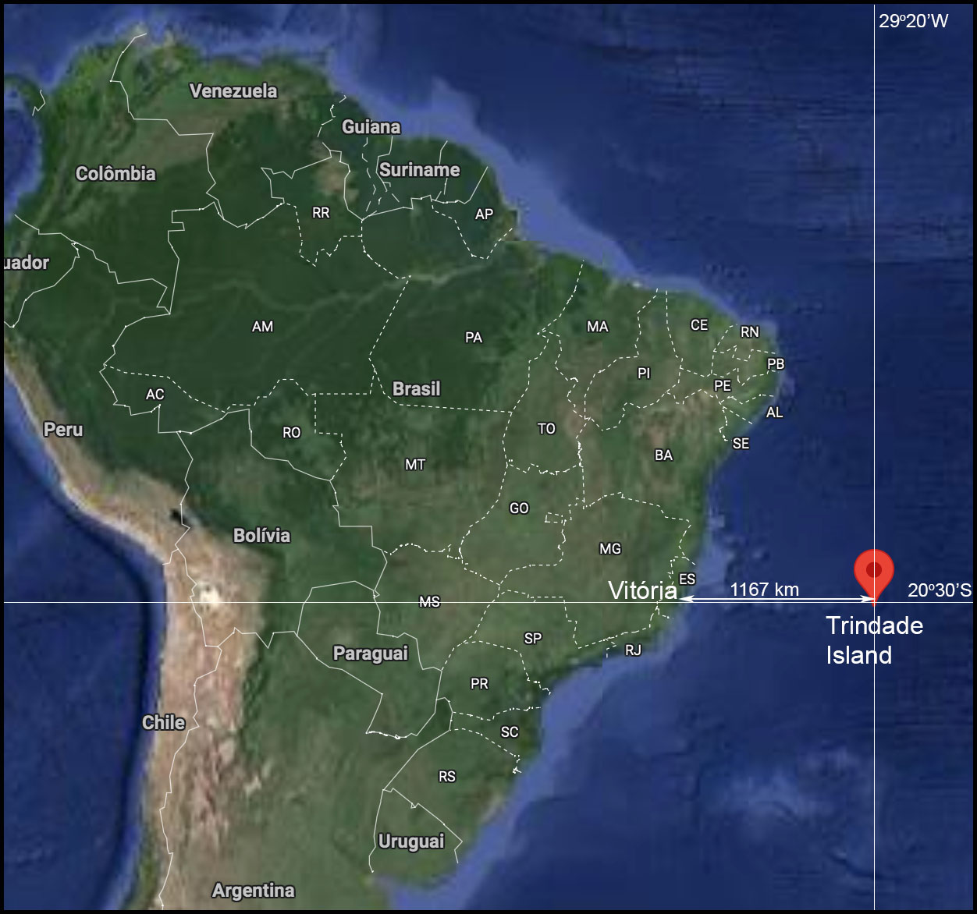
Figure 1. Location of Trindade Island (modified from Google Maps).

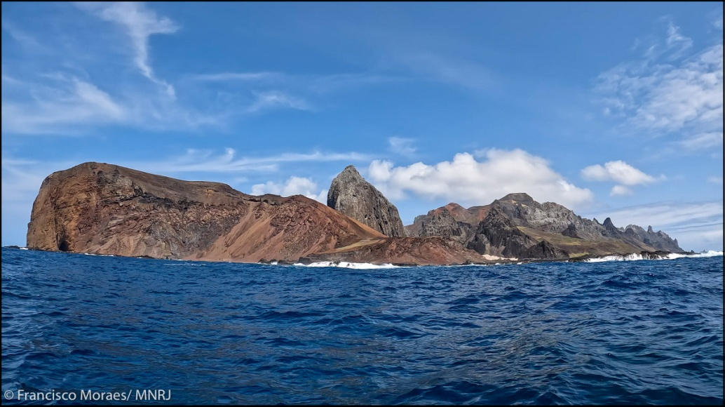
Figure 2. Trindade Island. The Big Wall Volcano (“Vulcão do Paredão”) is seen on the left (South), Turtles Beach ("Praia das Tartarugas") on the center/right, and Goat Beach (“Praia das Cabritas”) on the far right (North). Image by Francisco Moraes/MNRJ.

3. METHODS
From 21 to 25 September 2023, the 124th PROTRINDADE scientific expedition was conducted at Trindade Island. Six localities around the island were selected for exploration through SCUBA and free diving (Fig. 3), following informal indications from the Brazilian Navy divers and authors' previous observations about the possible existence of marine caves. These persons were chosen for interviews due to their wide knowledge of the diving sites around the island. A stretch 1500 m long off Andradas Beach and Turtles Beach was explored through free diving with a plana-sub towed by a boat; no collections were made there. The extension of the searches in the other sites varied from 15 to 200 m long (Table 1).
Underwater footage and photographs were taken using a GoPro 10 camera with two 1,300 lumens lighting. To characterize the sponge fauna of submarine caves and other disphotic environments, the sponge species in these sites were filmed and photographed, but due to time limitations only the most common species were collected for identification in the laboratory.
Samples of the most common sponge species were collected, preserved in 70% ethanol and deposited at the Porifera Collection of the Museu Nacional, Universidade Federal do Rio de Janeiro, Brazil (http://labpor.hopto.org/fmi/webd/Porifera_MNRJ-30-04-2023) under the Register Numbers MNRJ 29709–29725. Identification of the samples collected was based on external morphology and skeletal characters such as spicule types, fibers shape and architecture of the skeleton, following traditional methods (e.g., Hajdu et al., 2011). Some sponges not collected but with distinctive morphology were tentatively identified based only on external morphology through underwater photographs (Table 2).

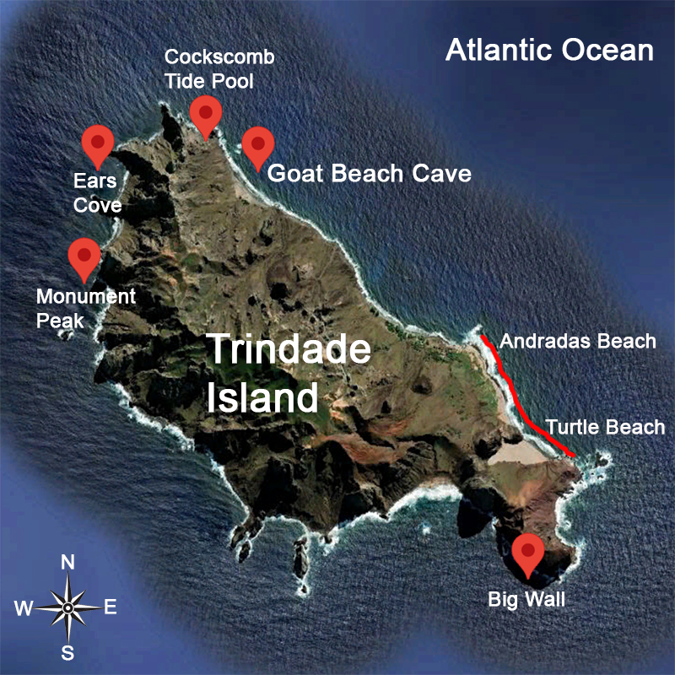
Figure 3. Location of sampling sites at Trindade Island (modified from Google Earth).

Diving site | Geographic  Coordinates | Extension of search (m) | Habitat | Maximum depth of site (m) | Depth of cavity entrance (m) | Length of cavity (m) | Entrance height (m) | Entrance width (m)
Big Wall | 20°31'41.7"S 29°18'16.1"W | 200 | tunnel | 27 | 0 | ~50 | 3 | 3
Cockscomb Tide Pool | 20°29'23.4"S 29°20'02.1"W | 15 | disphotic cavity | 2 | 1 | 1 | 1 | 2
Ears Cove | 20°29'37.5"S 29°20'35.1"W | 150 | canyon | 5 | 5 | - | - | -
Goat Beach | 20°29'37.4"S 29°19'45.2"W | 150 | cave | 8 | 5–6 | >6 | 1 | 3
Monument Peak | 20°30'07.1"S 29°20'41.3"W | 150 | disphotic cavity | 15 | 15 | 2 | 2 | 2
Table 1. Features of diving sites and cavities studied on Trindade Island in September 2023. Brazilian names of sites: Big Wall = Paredão; Goat Beach = Praia das Cabritas; Monument Peak = Pico do Monumento; Ears Cove = Enseada das Orelhas; Cockscomb Tide Pool = Piscina de Maré da Crista do Galo.

4. RESULTS

Base of Monument Peak
The Monument Peak (“Pico do Monumento”, in Portuguese) is located at the NW side of the island (Figs 3, 4). The base of peak was examined underwater down to 17 m depth (Fig. 5). The bottom consists mainly of large boulders forming small cavities with disphotic zones. Only one significant cavity was found, at 15 m depth, with an entrance approximately 2 m wide by 1 m high (Table 1; Fig. 5E-H). Three smaller entrances illuminate the edges, but the center and the ceiling of the cavity is a disphotic zone. There is only weak water flow and sponges (Table 2), polychaetes and ascidians are common. Reports of other researchers indicate the possible presence of larger underwater cavities at shallower depths, but it was not possible to investigate the areas closer to the shore due to the strong water movement imposed by wave action.

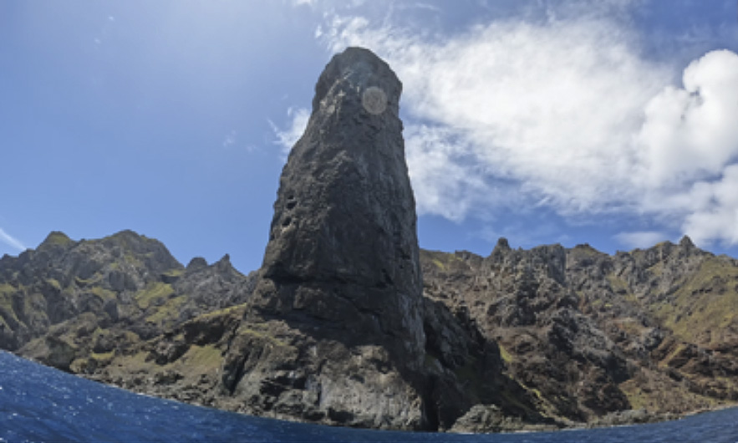
Figure 4. Monument Peak, located on the NW shore of Trindade Island. Image by Francisco Moraes/MNRJ.

Table 2. Sponge species collected and/or photographed at five diving sites on Trindade Island. MNRJ, register number at the Porifera Collection of Museu Nacional, Rio de Janeiro. Brazilian names of sampling sites: Big Wall = Paredão; Goat Beach Cave = Caverna da Praia das Cabritas; Monument Peak = Pico do Monumento; Ears Cove = Enseada das Orelhas; Cockscomb Tide Pool = Piscina de Maré da Crista do Galo. n. c., not collected (photographs only).
Locality | Species | MNRJ | Habitat | Light condition
Big Wall | Agelas cf. dispar Duchassaing & Michelotti, 1864 | 29720 | vertical and negative walls | photic and disphotic
 | Aiolochroia crassa (Hyatt, 1875) | 29718 | vertical wall | photic
 | Ircinia felix (Duchassaing & Michelotti, 1864) | 29719 | vertical wall | photic
 | Verongula gigantea (Hyatt, 1875) | n. c. | sub-horizontal rocks | photic
 | Plakinastrella microspiculifera Moraes & Muricy, 2003 | n. c. | sub-horizontal and negative rocks | disphotic
 | Ectyoplasia ferox (Duchassaing & Michelotti, 1864) | n. c. | vertical walls | photic
Cockscomb | Chondrilla caribensis Rützler et al., 2007 | 29721, 29722 | vertical walls | photic
Tide Pool | Chondrosia collectrix (Schmidt, 1870) | 29724 | vertical walls | photic
 | Ectyoplasia ferox (Duchassaing & Michelotti, 1864) | n. c. | vertical walls | photic
 | Mycale sp. | 29725 | vertical walls | photic
 | Plakinastrella microspiculifera Moraes & Muricy, 2003 | 29723 | cavities | disphotic
Ears Cove | Aiolochroia crassa (Hyatt, 1875) | 29716 | vertical walls | photic
 | Chondrosia sp. white | 29717 | cavities | disphotic
 | Plakinastrella microspiculifera Moraes & Muricy, 2003 | n. c. | vertical and negative rocks | disphotic
 | Topsentia ophiraphidites (de Laubenfels, 1934) | n. c. | vertical walls | disphotic
Goat Beach | Agelas sp. white | 29714 | cave | disphotic
Cave | Agelas cf. clathrodes Duchassaing & Michelotti, 1864 | n. c. | cave | disphotic
 | Agelas cf. dispar Duchassaing & Michelotti, 1864 | n. c. | cave | disphotic
 | cf. Diplastrella megastellata Hechtel, 1965 | n. c. | cave | disphotic
 | Scalarispongia sp. | 29715 | cave | disphotic
 | cf. Spirastrella hartmani Boury-Esnault et al., 1999 | n. c. | cave | disphotic
 | Plakinastrella microspiculifera Moraes & Muricy, 2003 | 29712 | cave | disphotic
Monument | Agelas sp. white | n. c. | cavities | disphotic
Peak | Aiolochroia crassa (Hyatt, 1875) | 29713 | vertical walls | photic
 | cf. Diplastrella megastellata Hechtel, 1965 | n. c. | cavities | disphotic
 | Ectyoplasia ferox (Duchassaing & Michelotti, 1864) | 29711 | vertical walls and cavities | photic and disphotic
 | cf. Petrosia weinbergi van Soest, 1980 | n. c. | vertical walls | photic
 | Plakinastrella microspiculifera Moraes & Muricy, 2003 | 29712 | cavities | disphotic
 | cf. Spirastrella hartmani Boury-Esnault et al., 1999 | n. c. | cavities | disphotic
 | Topsentia ophiraphidites (de Laubenfels, 1934) | 29709, 29710 | vertical walls | photic and disphotic

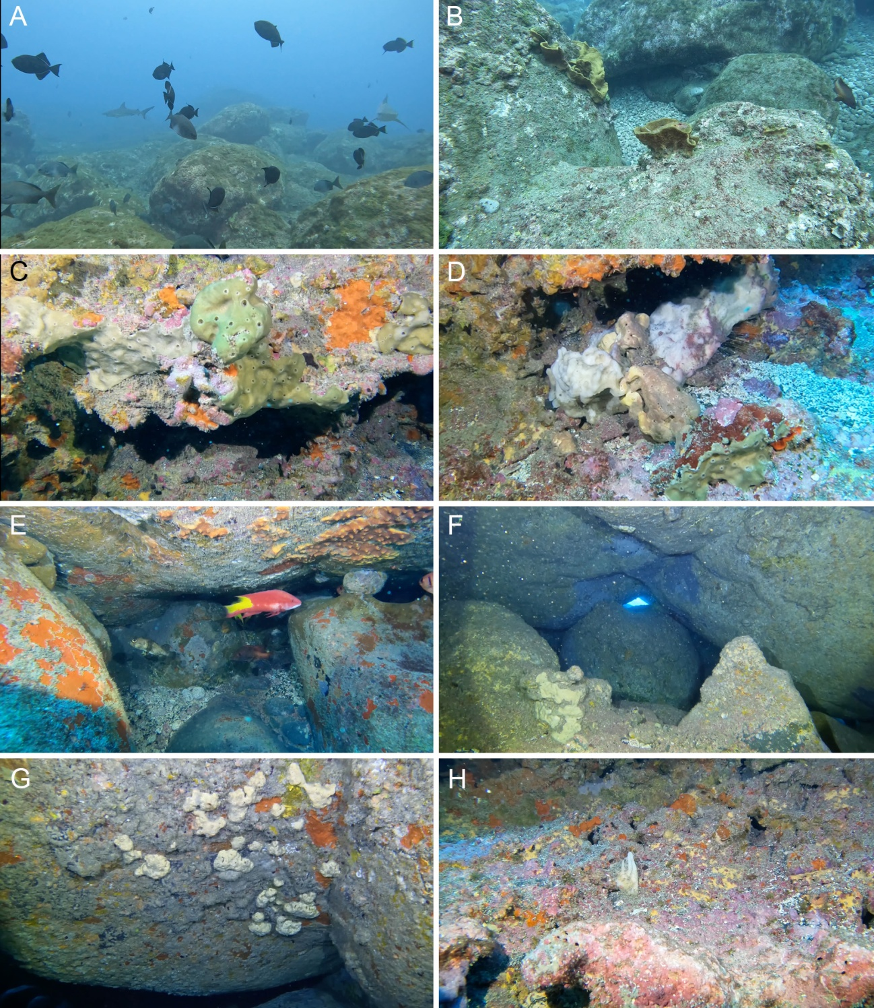
Figure 5. Underwater views of the Base of Monument Peak diving site. A-B, horizontal rocky bottoms with large boulders with abundance of the sponge Verongula gigantea in B. C-D, vertical walls showing the sponges Petrosia weinbergi on C and Topsentia ophiraphidites on D. E-H, views inside semi-dark cavities, showing fish and the sponges Ectyoplasia ferox on E (top), Spirastrella hartmani on E (left), Agelas sp. on F and G, cf. Diplastrella megastellata on G (yellow) and Topsentia ophiraphidites on H (white, on center). Images by Francisco Moraes/MNRJ.

Ears Cove
Ears Cove (“Enseada das Orelhas”, in Portuguese) is also located at the NW part of Trindade Island, just north of Monument Peak (Figs 3, 6A). Its middle section was explored from 2 to 15 m depth. There is a small canyon at 5 m depth with vertical and negative walls with few parts coming together, forming small roofs but no real cave (Table 1; Fig. 6B-F). However, the environment is well lit and the water flow is very intense. There are many rounded pebbles at the bottom of the channel, which probably roll with the currents and waves, and therefore there are few encrusting organisms on the floor. Sponges (Table 2) and polychaetes dominate on the walls and ceiling. Reports from other divers suggest that there are small grottoes and dark tunnels at the sides of the cove, but we were unable to explore these places.

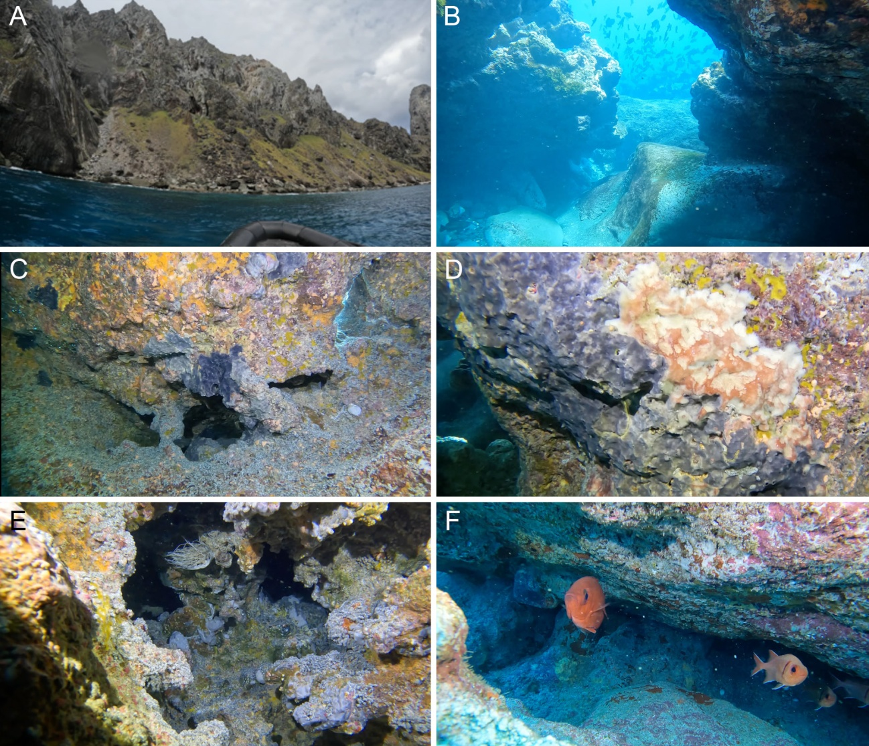
Figure 6. Ears Cove (“Enseada das Orelhas”). A, general view of the shore out of the water. B, narrow channel at 5 m depth with horizontal rocky bottom between vertical walls. C-D, sponges on vertical walls and grooves (mainly Plakinastrella microspiculifera and Topsentia ophiraphidites). E-F, inner side of small cavities showing sponges and fishes. Images by Francisco Moraes/MNRJ.

Big Wall
The Big Wall (“Paredão”, in Portuguese) is the external side of an extinct volcano, located at the Southern tip of Trindade Island (Figs 2, 3, 7A). The almost vertical wall continues underwater to 26 meters depth. Sponges such as Ircinia felix, Aiolochroia crassa and Agelas dispar are very common, especially on vertical walls and crevices (Table 2; Fig. 7B-F). Verongula gigantea dominates on horizontal and exposed bottoms, indicating the sponge resilience to strong swells reaching the island from south (Fig. 7B, C). This sponge species has a remarkable skeleton architecture made of reinforced sponging fibers that create a physically resistant mesh. Several fragments of this species can be found on the beaches of Trindade Island as remains of the fibrous nature of the sponges (Moraes et al., 2006; 2011).
There is a large semi-submerged tunnel opening at the Big Wall point (Table 1; Figs 7A, 8). This tunnel is subjected to very strong wave surge, making it extremely difficult to explore. Reports from other researchers indicate the likely existence of small caves after the slab emerging from the wall, in NW direction towards Prince Beach ("Praia do Príncipe, in Portuguese), but we were unable to find them to date.

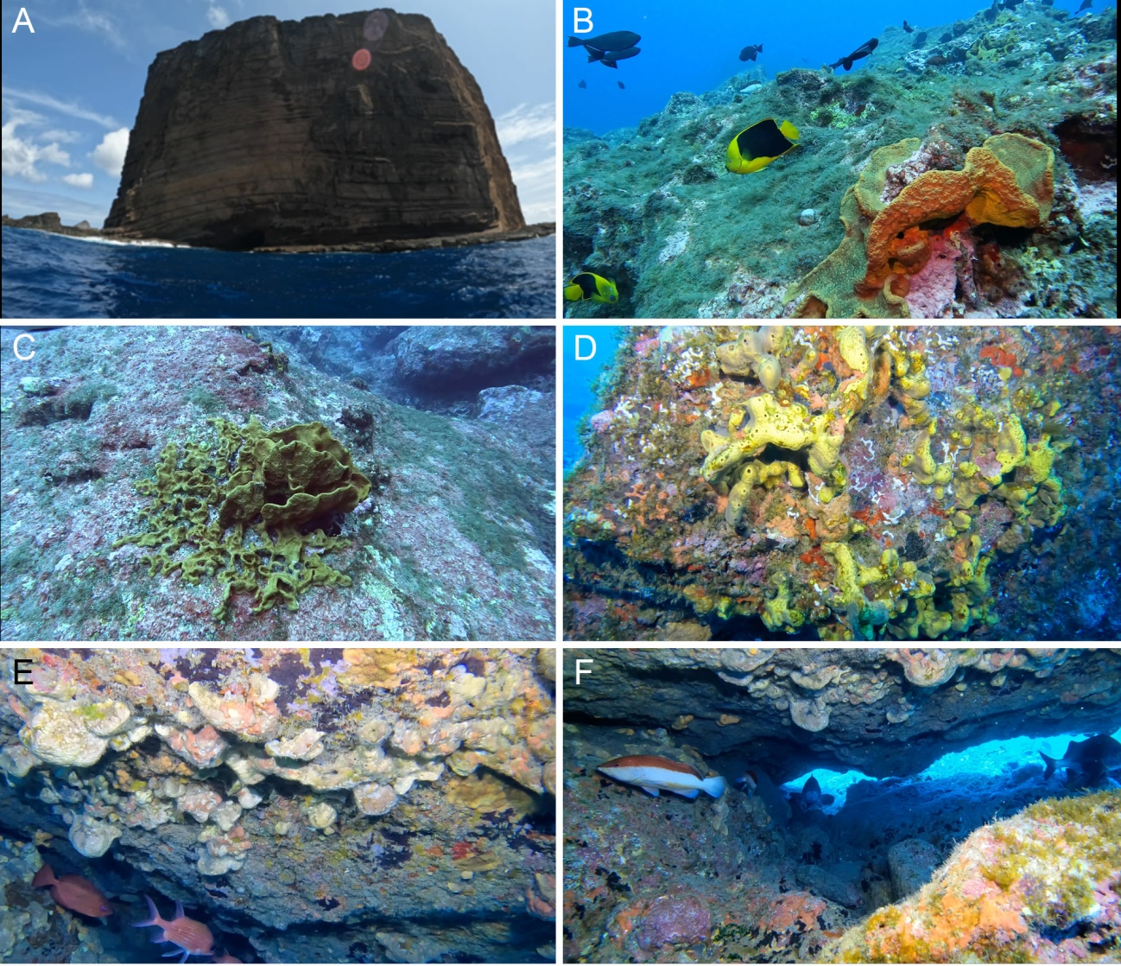
Figure 7. Big Wall (“Paredão”). A, general view of the shore out of the water. B-C, sub-horizontal rocky bottom with the sponge Verongula gigantea. D, Aiolochroia crassa on vertical wall. E, ceiling of disphotic cavity dominated by Agelas dispar and Plakinastrella microspiculifera. F, disphotic cavity with sponges and fishes. Images by Francisco Moraes/MNRJ.

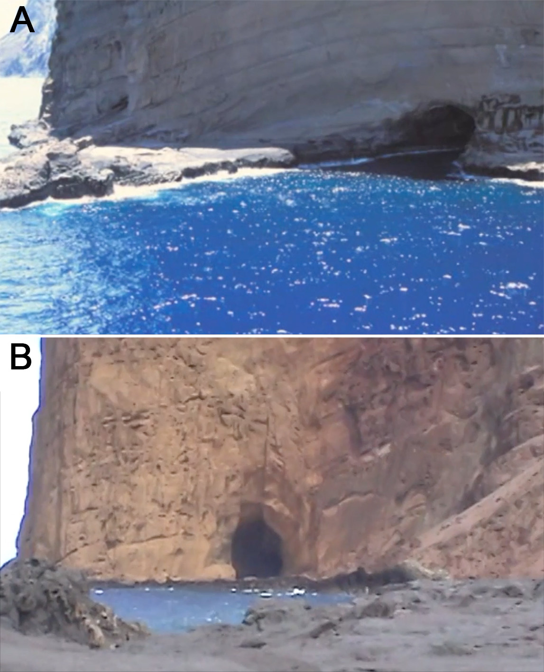
Figure 8. Big Wall Tunnel (“Túnel do Paredão”). A, Seaward (South) entrance (arrow). B, Landward (North) entrance.

Off Andradas Beach and Off Turtles Beach
A wide region off Andradas Beach and Turtles Beach (“Praia dos Andradas” and “Praia das Tartarugas”, in Portuguese), located at the Southeastern part of the island (Fig. 3), was explored through free diving towed by a boat. The towing was parallel to the coast, at a maximum depth of 8 m, aiming to locate small caves reported by the Brazilian Navy divers. Off Andradas Beach, the bottom is relatively complex, with channels deeper than the main slab, vertical walls and small shaded burrows. Off Turtles Beach, the bottom is rocky and flat, with low complexity. No caves were found, but further exploration of this area with SCUBA diving is warranted.

Cockscomb Tide pool
The Cockscomb Tide Pool (“Piscina da Crista do Galo”, in Portuguese) is located at the Northern tip of Trindade Island (Fig. 3). It is elongate and measures approximately 15 m long by 2–3 m wide, with a maximum of 2 m depth (Fig. 9A). This pool was explored through free diving only. It has small cavities in its deepest portion, approximately 1 m long, with small disphotic portions (Table 1). The sponges are abundant in the tide pool, especially Chondrilla caribensis, Ectyoplasia ferox, Chondrosia collectrix, Mycale sp. and Plakinastrella microspiculifera (Table 2; Fig. 9C-E). Crustose coralline algae (thinly encrusting and fruticose forms) and stony corals (Siderastrea stellata Verril, 1868; Favia gravida Verril, 1868) are also common on the vertical walls (Fig. 9D) and sea urchins Diadema antillarum (Philippi, 1845) hide in small cavities (Fig. 9E). It was noted the presence of a typical mixing layer of waters of different densities, indicating a possible underground source of fresh water reaching the pool.

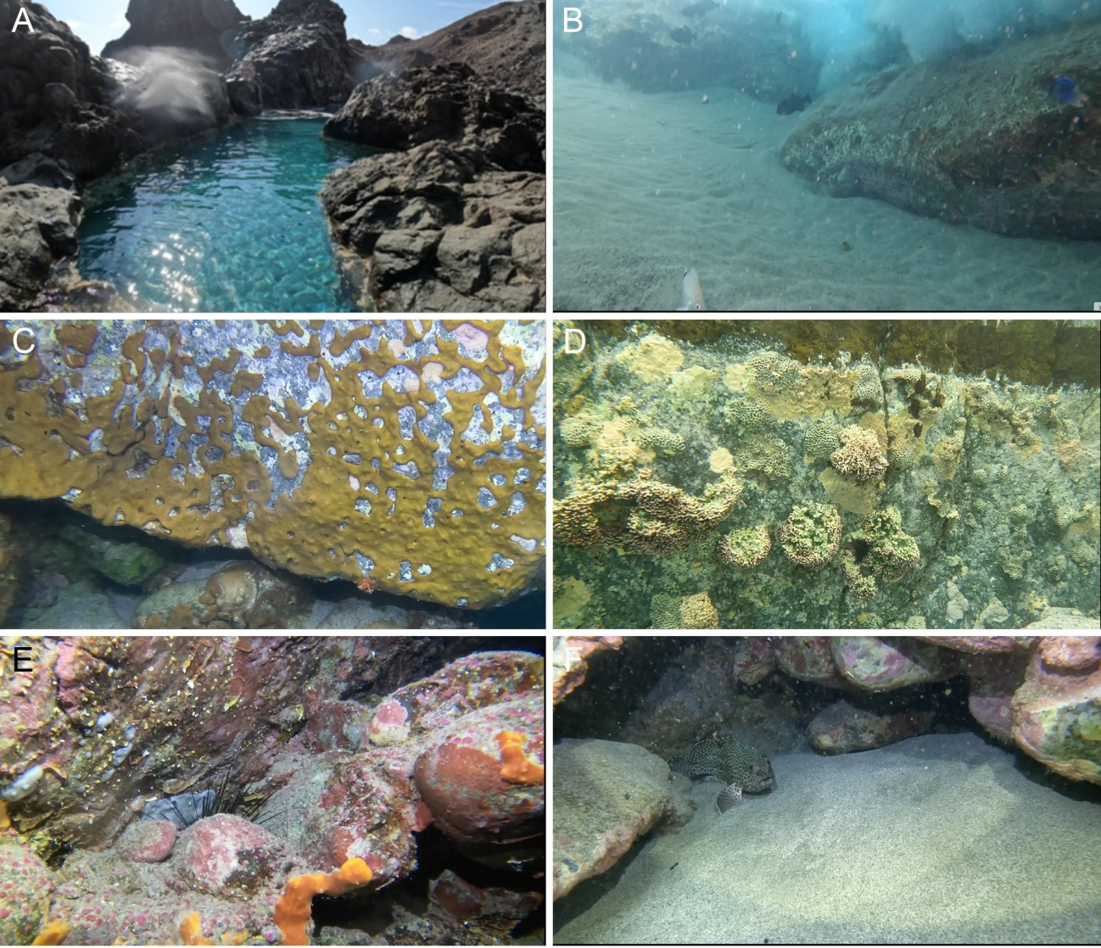Figure 9. Cockscomb Tide Pool (Piscina de Maré da Crista do Galo). A, general view. B, sub-horizontal sandy bottom. C, vertical wall with Chondrilla caribensis. D, vertical wall with crustose coralline algae and corals (Favia gravida). E, wall and crevice with the sponge Ectyoplasia ferox and the sea urchin Diadema antillarum. F, small cavity with crustose coralline algae and a fish. Images by Francisco Moraes/MNRJ.

Goat Beach Cave
Goat Beach (“Praia das Cabritas”, in Portuguese) is located at the Northeastern part of the island, near Cockscomb Tide Pool (Figs 2, 3), and it is the only site where a strict submarine cave was found in our expedition. All other sampling sites herein investigated were not considered strict caves, yet previous records have indicated such presence at Trindade Island (unpublished data). The cave is located around the middle of Goat Beach, a few meters away from the wave-breaking zone.
The cave entrance is located at 5–6 m depth on a small embankment that goes from 3 to 8 m depth. The entrance is narrow, approximately 2 m long by 1 m high (Figs 10, 11A). It opens into a semi-dark room with approximately 5 m long and wide and 2–3 m high (Table 1; Fig. 10). The bottom is rocky to sandy, at a maximum of 8 m depth. The walls and ceiling are covered mainly by the sponges Agelas dispar, Agelas sp., cf. Diplastrella megastellata and cf. Spirastrella hartmani, together with a few polychaetes (Table 2; Fig. 11B-E). Spiny lobsters (Panulirus cf. argus Latreille, 1804) are common on the bottom and in crevices (Fig. 11F). In the end of the semi-dark room, there are some narrow passages that lead to darker parts of the cave, which could not be explored yet.
There is significant water flow and sand suspension inside the cave, suggesting that there are secondary openings beyond the main entrance. According to reports of the Brazilian Navy divers, there is another submarine cave towards the middle of Goat Beach, but we were unable to find it.

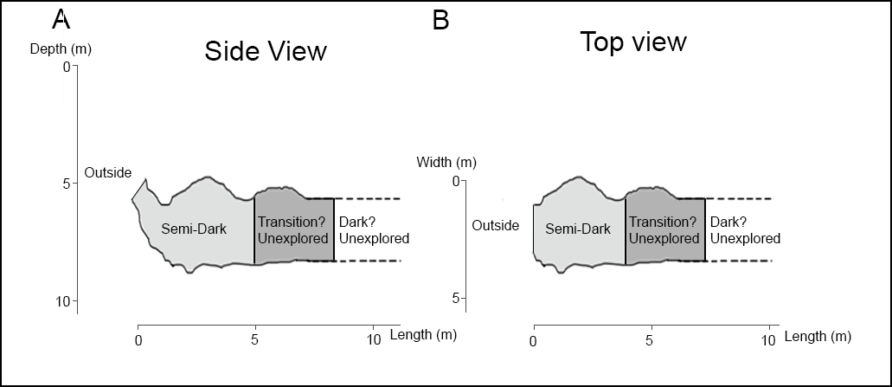
Figure 10. Schematic sections of Goat Beach Cave. A, lateral view. B, upper view.

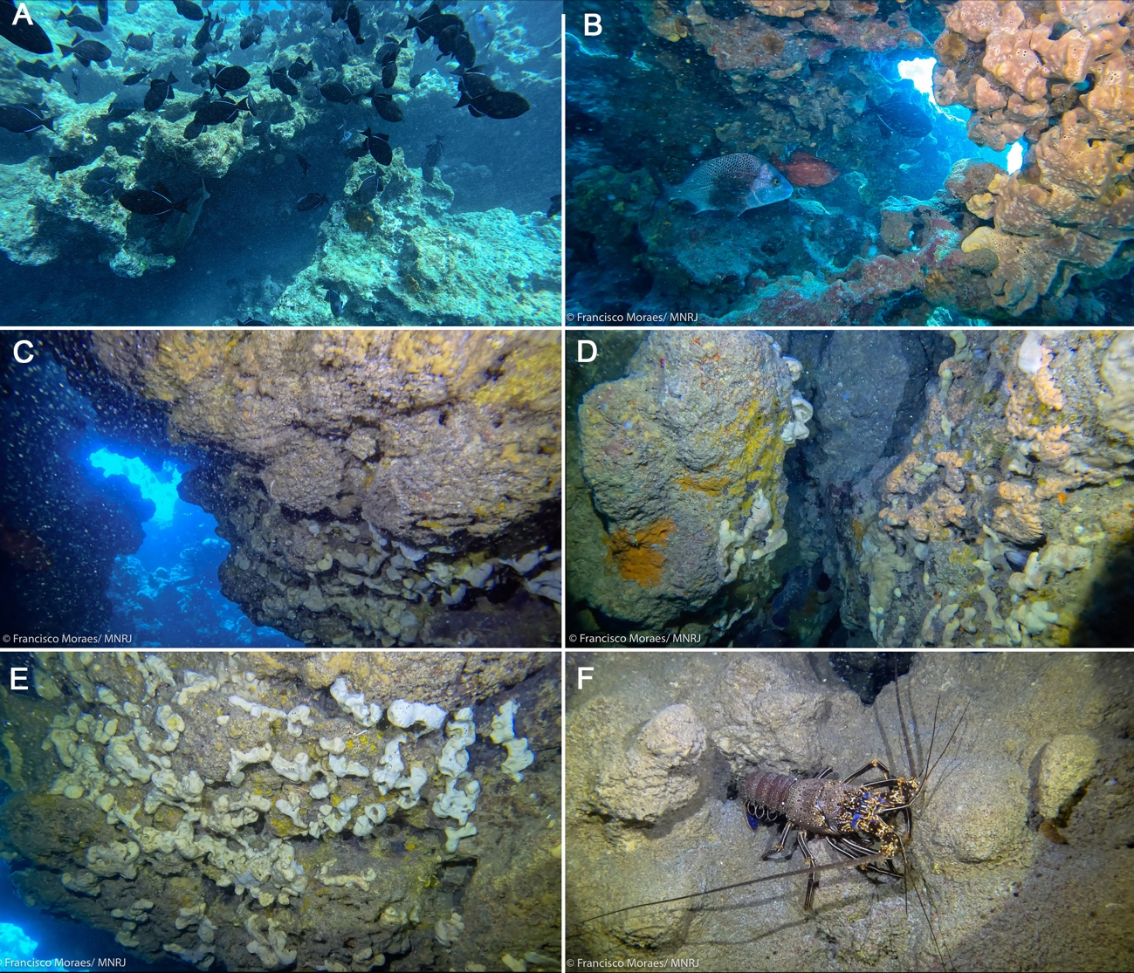
Figure 11. Goat Beach Cave (“Caverna da Praia das Cabritas”. A, cave entrance viewed from outside. B, C, cave entrance viewed from inside (center) and wall of the semi-dark zone dominated by the sponges Agelas dispar (in B), cf. Diplastrella megastellata and Agelas sp. (in C) and of the transition zone with few organisms (center). D, E, walls of the semi-dark zone dominated by the white sponge Agelas sp., brown Agelas dispar, yellow Diplastrella megastellata, and orange cf. Spirastrella hartmani. F, beginning of the transition zone, with low benthic cover and a spiny lobster (Panulirus cf. argus). Images by Francisco Moraes/MNRJ.

5. DISCUSSION
In this study, we explored six sites in Trindade Island and found a small submarine cave on Goat Beach (Praia das Cabritas). This is the first report of a submarine cave in Trindade Island. Although it has not be fully explored yet, our preliminary investigation showed that it has a disphotic zone and a transition zone with reduced benthic cover. The existence of an aphotic in this cave, similar to that of caves in the Mediterranean and Fernando de Noronha Archipelago (Gerovasileiou & Bianchi, 2021; Muricy et al., 2024), and of a secondary entrance remain to be investigated. Some sponge species found in this cave, such as cf. Diplastrella megastellata, cf. Spirastrella hartmani and Agelas sp., also occur in Sapata and Ilha do Meio caves, in Fernando de Noronha Archipelago (Muricy et al., 2024). The occurrence of these cave-dwelling species shows the importance of marine caves in oceanic islands for the protection of the benthic fauna. In contrast, some species, especially Verongula gigantea and Aiolochroia crassa, were found only in photic habitats. This habitat preference could be related to association with photosynthetic microorganisms, but this hypothesis remains to be tested.
The semi-submerged tunnel at Big Wall (“Túnel do Paredão”) is famous for stories of a hidden pirate’s treasure, which are probably false but that resulted in the death of a curious Brazilian Navy diver inside it in 1979 (Braga, 2018). The benthic community in the tunnel is very sparse due to the extremely strong wave action.
Many other diving sites still remain to be investigated at Trindade Island. According to reports from other researchers and the Brazilian Navy divers, there might be other cave systems with relevant potential for the presence of exclusive sponge species and other cave-dwelling organisms around the island. However, it seems that other caves at Trindade Island, if they indeed exist, would be smaller than those of Fernando de Noronha (Muricy et al., 2024). Due to the logistical difficulty of diving operations and the strong dependence on favorable weather and sea conditions at Trindade Island, it is necessary to stay longer and in more favorable weather seasons on the island to investigate other sites. Further exploration of these sites and of the interior of Goat Beach Cave are greatly needed.

Funding
GM received grants from Conselho Nacional de Desenvolvimento Científico e Tecnológico (CNPq-31/2019) [grant numbers 443302/2019-7 (PROILHAS) and 441747/2020-5 (PROTAX)], and Fundação Carlos Chagas Filho de Amparo à Pesquisa do Estado do Rio de Janeiro [grant FAPERJ CNE 2018 number E-26/202.898/2018-BOLSA]. JS received post-doctoral fellowship from FAPERJ [grant FAPERJ Pós-Doutorado Nota 10 number E-26/204.366/2021].

Acknowledgements
The authors are grateful to the Brazilian Navy for logistical support during the expedition to Trindade Island and especially to Sub-Officer Diver Nonato for support during diving operations. Carolline Pequeno helped with the identification of the sponges and curation of the Porifera Collection of Museu Nacional, Universidade Federal do Rio de Janeiro. We are also grateful to the Instituto Chico Mendes de Conservação da Biodiversidade (ICMBio) for the research permit in the Trindade Island Marine Protected Area (SISBIO license number 73826-9).

References

ÁLVAREZ, F.; DURÁN, B.; MEACHAM, S. Anchialine fauna of the Yucatan Peninsula: Diversity and conservation challenges. In JONES, R.W.; ORNELAS-GARCÍA, C.P.; PINEDA-LÓPEZ, R.; ÁLVAREZ, F., (Eds.), Mexican Fauna in the Anthropocene; Springer: Cham, pp. 287–301, 2023.
ALVES, R. J. V. Ilha da Trindade & Arquipélago Martin Vaz: um ensaio geobotânico. Brasil: Serviço de Documentação da Marinha, 1998.
AZEVEDO, F.C.; PADUA, A.Q.; MORAES, F.; ROSSI, A.L.; MURICY, G. & KLAUTAU, M. Taxonomy and phylogeny of calcareous sponges (Porifera: Calcarea: Calcinea) from Brazilian mid-shelf and oceanic islands. Zootaxa, v. 4311, p. 301–344, 2017. https://doi.org/10.11646/zootaxa.4311.3.1
BOURY-ESNAULT, N.; KLAUTAU, M.; BÉZAC, C.; WULFF, J.; SOLÉ-CAVA, A.M. Comparative study of putative conspecific sponge populations from both sides of the Isthmus of Panama. Journal of the Marine Biological Association of the United Kingdom, v. 79, n. 1, p. 39-50, 1999.
BRAGA, E. As mortais ondas camelos da Ilha da Trindade. Vídeo História, 2018. http://www.videohistoria.com.br. Acessed in January 08, 2025.
CORDANI, U. Idade do vulcanismo no Oceano Atlântico Sul. Boletim do Instituto de Geociências e Astronomia, v. 1, p. 9–75, 1970.
CORDEIRO, C.A.M.M.; FLOETER, S.R.; FERREIRA, C.E.L. Biogeographic patterns of Brazilian rocky reef fauna. In: COUTINHO, R., CHRISTOFOLETTI, R.A. (Eds.) Brazilian rocky shores. Brazilian marine biodiversity. Springer, Cham, 2024. https://doi.org/10.1007/978-3-031-67206-4_2
DE REZENDE, D.H.C.; MARTINS-CUNHA, K.; MONTEIRO, M.; ALVES-SILVA, G.; DRECHSLER-SANTOS, E.R.; FERNANDES, G.W.; GÓES-NETO, A. Lost in the voidness of the Atlantic Ocean: a synthesis of publication trends, biological diversity, and conservation in Trindade Island. Biodiversidade Brasileira, v. 13, n.1, 2023.
DUCHASSAING DE FONBRESSIN, P.; MICHELOTTI, G. Spongiaires de la mer Caraïbe. Natuurkundige verhandelingen van de Hollandsche maatschappij der wetenschappen te Haarlem, v. 21, n. 2, p. 1-124, 1864.
GEROVASILEIOU, V.; BIANCHI, C.N. Mediterranean marine caves: A synthesis of current knowledge. Oceanography and Marine Biology: An Annual Review, v. 59, p. 1–88, 2021.
GEROVASILEIOU, V.; VOULTSIADOU, E. Marine caves of the Mediterranean Sea: A sponge biodiversity reservoir within a biodiversity hotspot. PLoS ONE, v. 7, e39873, 2012.
GUNN, J. Encyclopedia of Caves and Karst Science. Fitzroy Dearborn, New York, 2004.
HAJDU, E.; PEIXINHO, S.; FERNANDEZ, J.C.C. Esponjas marinhas da Bahia - guia de campo e laboratório. Museu Nacional, Rio de Janeiro, 2011.
HARMELIN, J.G.; VACELET, J.; VASSEUR, P. Les grottes sous-marines obscures: Un milieu extrême et un remarquable biotope refuge. Téthys, v. 11, p. 214–229, 1985.
HART, C.W., JR.; MANNING, R.B.; ILIFFE, T.M. The fauna of Atlantic marine caves: Evidence of dispersal by sea floor spreading while maintaining ties to deep waters. Proceedings of the Biological Society of Washington, v. 98, p. 288–292, 1985.
HECHTEL, G.J. A systematic study of the Demospongiae of Port Royal, Jamaica. Bulletin of the Peabody Museum of Natural History, v. 20, p. 1-103, 1965.
HYATT, A. (1875). Revision of the North American Poriferae; with remarks upon foreign species. Part I. Memoirs of the Boston Society of Natural History, v. 2, p. 399-408, 1875.
LABOREL, J.; VACELET, J. Étude des peuplements d’une grotte sous-marine du Golfe de Marseille. Bulletin de l’Institut Océanographique, v. 1120, p. 1–20, 1958.
LATREILLE, P.A. Des langoustes du Muséum national d'Histoire naturelle. Annales du Muséum national Histoire naturelle, v. 3, p. 388-395, 1804.
LAUBENFELS, M.W. DE. New sponges from the Puerto Rican deep. Smithsonian Miscellaneous Collections, v. 91(17), p. 1-28, 1934.
MANNING, R.B.; HART, C.W.; JR., ILIFFE, T.M. Mesozoic relicts in marine caves of Bermuda. Stygologia, v. 2, p. 156–166, 1986.
MARTINS, A., OLAVO, G., COSTA, P.A.S. Reef fish in the Vitória-Trindade Seamount Chain of the Southwestern Atlantic: Biogeographical corridors and impact of fishing. Qeios, 2024 (open peer review).
MORAES, F.C. Esponjas das ilhas oceânicas brasileiras. Museu Nacional, Rio de Janeiro, 2011.
MORAES, F.C.; MURICY, G. Taxonomy of Plakortis and Plakinastrella (Demospongiae: Plakinidae) from oceanic islands off north-eastern Brazil, with description of three new species. Journal of the Marine Biological Association of the United Kingdom, v. 83, n. 2, p. 385-397, 2003.
MORAES, F.C.; VENTURA, M.; KLAUTAU, M.; HAJDU, E.; MURICY, G. Biodiversidade de esponjas das ilhas oceânicas brasileiras. In: Alves, R.J.V.; Castro, J.W.A. (Eds.), Ilhas Oceânicas Brasileiras: da Pesquisa ao Manejo. Brasília, Ministério do Meio Ambiente, Secretaria de Biodiversidade e Floresta, p. 147-177, 2006.
MOTOKI, K.; CAMPOS, T.; SANTOS, A.; HEILBRON, M.; BARÃO, L.; SICHEL, S.; et al. Interpretation of high-resolution remote sensing data for plio-pleistocene tectonic structures studies in the Trindade Island volcanic building, South Atlantic Ocean, Brazil. In CENGIZ, M.; KARABULUT, S. (Eds.), Formation and Evolution of Earth’s Crust. IntechOpen, p. 1-24, 2024. https://doi.org/10.5772/intechopen.107566
MURICY, G.; LAGE, A.; SANDES, J.; KLAUTAU, M.; PINHEIRO, U.; LAPORT, M.S.; DE OLIVEIRA, B.F.R.; PEQUENO, C.B.; LOPES, M.V. Sponge communities of submarine caves and tunnels on the Fernando de Noronha Archipelago, Northeast Brazil. Journal of Marine Science and Engineering, v. 12, p. 657, 2024. https://doi.org/10.3390/jmse12040657
PHILIPPI, R. A. Beschreibung einiger neuer Echinodermen nebst kritischen Bemerckungen über einige weniger bekannte Arten. Archiv für Naturgeschichte, v. 11, p. 344-359, 1845. Available online at https://www.biodiversitylibrary.org/page/6483274
PINHEIRO, H.; BERNARDI, G.; SIMON, T. et al. Island biogeography of marine organisms. Nature, v. 549, 82–85, 2017. https://doi.org/10.1038/nature23680
RÜTZLER, K.; DURAN, S.; PIANTONI, C. Adaptation of reef and mangrove sponges to stress: evidence for ecological speciation exemplified by Chondrilla caribensis new species (Demospongiae, Chondrosida). Marine Ecology, v. 28 (Suppl.1), p. 95-111, 2007.
SCHMIDT, O. Grundzüge einer Spongien-Fauna des atlantischen Gebietes. Wilhelm Engelmann: Leipzig, p. 1-88, 1870.
SOEST, R.W.M Van. Marine sponges from Curaçao and other Caribbean localities. Part II. Haplosclerida. In HUMMELINCK, P.W.; VAN DER STEEN, L.J. (Eds), Uitgaven van de Natuurwetenschappelijke Studiekring voor Suriname en de Nederlandse Antillen. No. 104. Studies on the Fauna of Curaçao and other Caribbean Islands, v. 62, n. 191, p. 1-173, 1980.
ULBRICH, M.N.C., MARQUES, L.S., LOPES, R.P. As ilhas vulcânicas brasileiras: Fernando de Noronha e Trindade. In: MANTESSO NETO, V.; BARTORELLI, A., CARNEIRO, C.R., BRITO NEVES, B.B. (Eds.). Geologia do continente Sul-Americano: evolução da obra de Fernando Flávio Marques de Almeida. Beca Produções Culturais, São Paulo, p. 555-573, 2004.
VERRILL, A.E. Notes on Radiata in the Museum of Yale College, with descriptions of new genera and species. No. 4. Notice of the corals and Echinoderms collected by Prof. C.F. Hartt, at the Abrolhos Reefs, Province of Bahia, Brazil, 1867. Transactions of the Connecticut Academy of Arts and Sciences, v. 1, n. 2, p. 351-376, 1868. Available online at https://biodiversitylibrary.org/page/13380325

